**Project A: swimming model and planetary system**

**Goal**

Design and draw two different 3D parts which have two or more sequential, moving joints.

**User-guide**

Open the html file, there are one sequential rectangles, which models the posture of swimming, and a planet system, where three small balls spin around a big ball.

1. Press a button “Spin<<” as following to make to the graphics rotate to left more quickly. If graphics are spinning towards right, the spinning speed will slow down.

P1

1. Press a button like P2 to make it graphics to spinning to right quickly.



P2

1. Press “Run/Stop” to run the movements of graphics or stop them.



P3

1. Use mouse to drag the graphic to observe graphic with different view.
2. Click on canvas with mouse to relocate the rotation center of planetary system。
3. Stop the graphic quickly through press “Space” on the keyboard.

**Result**

This is the beginning of my graphics. The smaller balls will spin around the biggest ball.

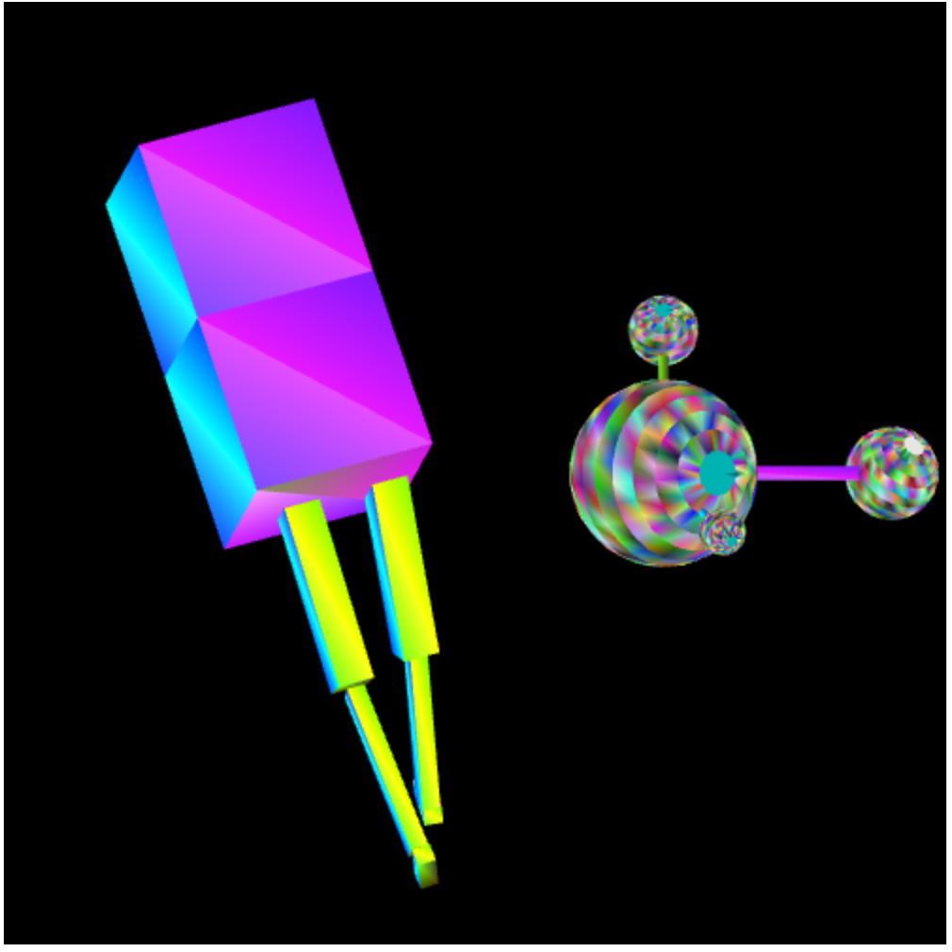

Figure 1

Then if dragging the graphic with mouse, the following picture appears.

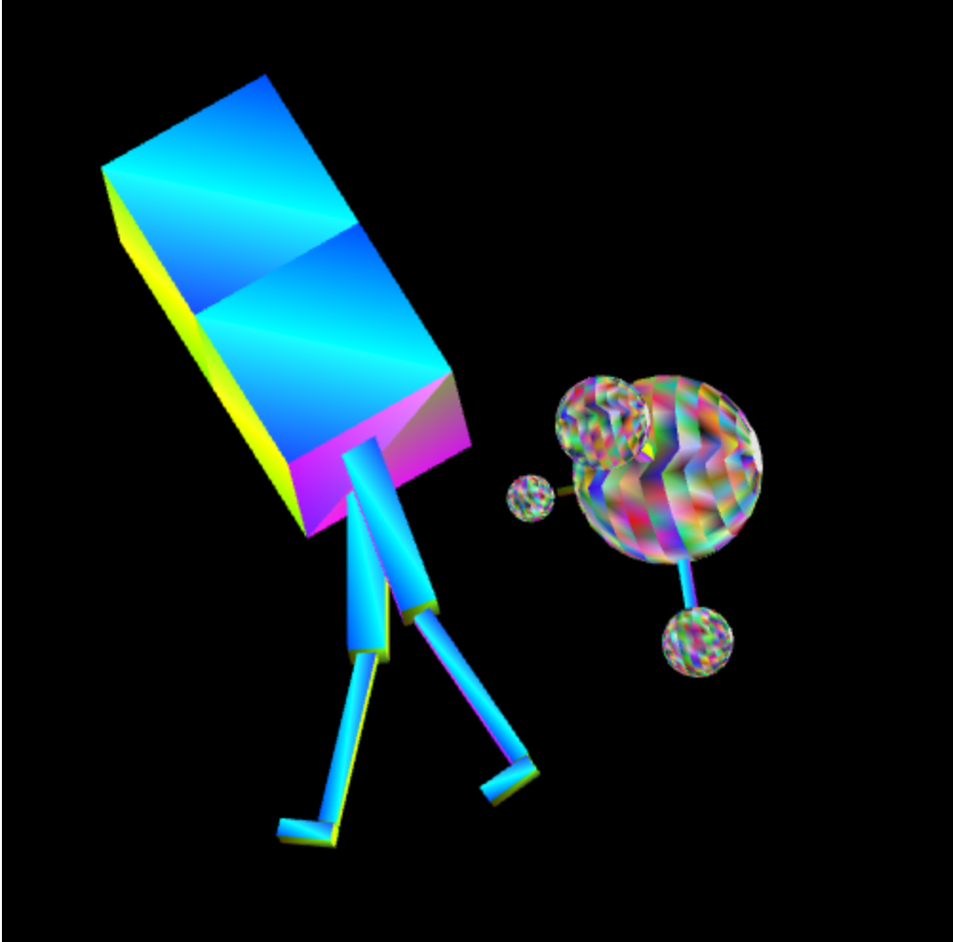

Figure 2

Clicking on the canvas, the planetary system will relocate at a new address.

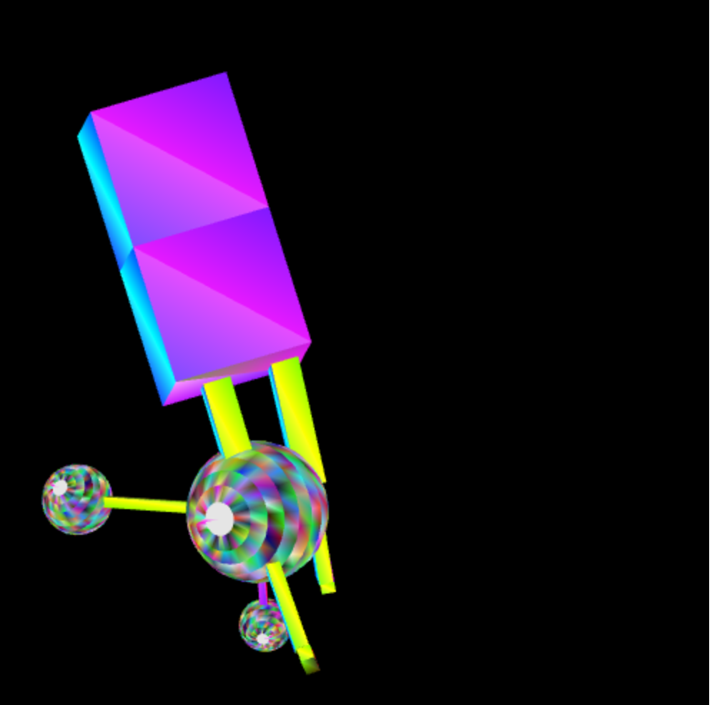

Figure 3

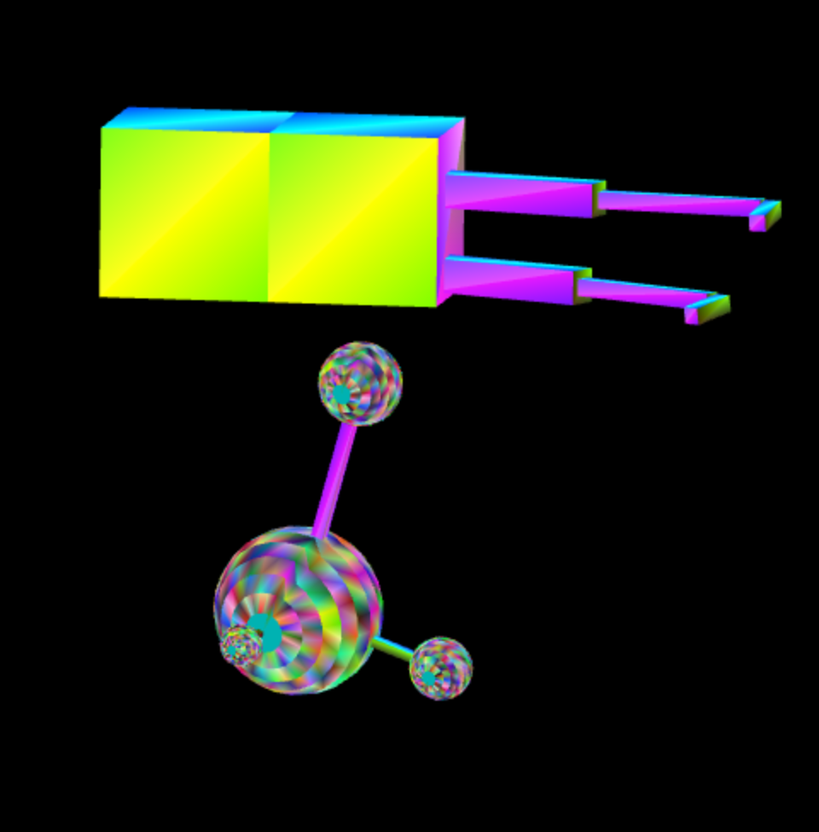

Figure 4

**Sketch of program’s scene-graph**

**The tree of swimming graphic**

Draw the first rectangle

(SetTranslate)

Draw the second rectangle

Draw the first thigh Draw the second thigh

Draw a clap Draw a clap

Foot foot

**The tree of planetary system**

Draw the sphere as sun

(SetTranslate)

Draw a strip Draw a strip Draw a strip

Draw a planetary Draw a planetary draw a planetary